# Service Centre Management (Calling)

**Service Centre Management (Calling)** is a software tool designed to facilitate the servicing and repair of products once their warranty period has expired. It provides services to various products of multiple brands. Software manages customer data and interactions and assigns task to the service engineer. It helps businesses organize customer information, track service activities, register feedback, provide analytics, and more. Core capabilities of SCM system include:

* Centralized customer database to store contact details, interactions, transaction history etc.
* Automation to register call, allocate engineer and track service processes.
* Enhanced customer service and support ticketing. Customer can query on job status and pending jobs.
* Analytics and reporting on customer data, product serviced etc.

## Existing System

The service center currently employs a manual process for registering complaints in a logbook and then assigning tasks to engineers. Doing things by hand is slow and can cause error and delays. Scheduling service and communicating with customers is time consuming which leads to lost time and dissatisfied clients. Additionally, communication among employees within the service center can be challenging in a manual system.

## Advantage Over Manual

Perhaps the best part about using software for service management is that it makes the lives of employees easier by automating and optimizing processes. Advanced service management software automates the entire support ticketing process, automatically assigning tickets, sending relevant notifications, and updating statuses. Not only does this streamline processes, but it saves time and ensures valuable employee resources aren’t being wasted on redundant, manual tasks. Service centers which embrace automation provide exceptional service quality resulting in happy customer and more in-flow of business.

## Proposed System Flow

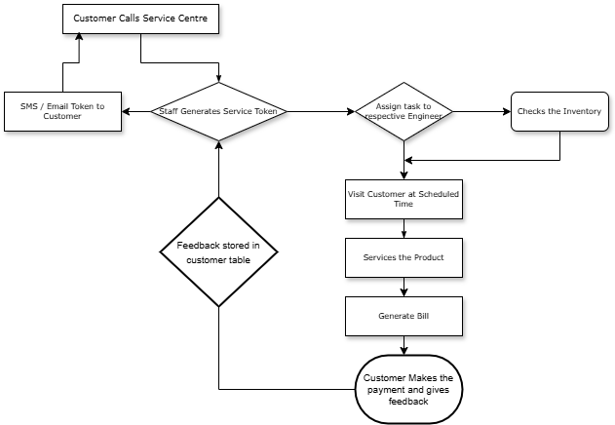

## Technologies Used

There are many different types of software development technologies available, each with its own strengths and weaknesses. The technology used to develop Service Centre Management program is Python. For database MySql is used.

#### **Python**

Python, renowned for its simplicity and readability, ranks among the top choices for web development and data science. It’s currently most popular programming language. It is a high-level, general-purpose language used for diverse tasks, including data analysis, visualization, web development, prototyping, and automation. Its open-source nature allows programmers to tailor its source code to meet their requirements.

Pythons Machine Learning (ML) technology will be used for analytics and reporting.

#### **MySql**

SQL is a computer language for database manipulation, retrieval, and updating. SQL enables apps to communicate with the data in their back-end databases. MySQL is a widely used open-source relational database management system (RDBMS). It is known for its speed, reliability, and ease of use.

MySQL is a good choice for a variety of applications, including websites, e-commerce platforms, and customer relationship management (CRM) systems.

## Points Not Covered

* Integration of inventory maintenance module
* Spare parts purchase order
* Employee management